https://www.youtube.com/watch?v=TwzEHPqqS6Q#t=106.9780962

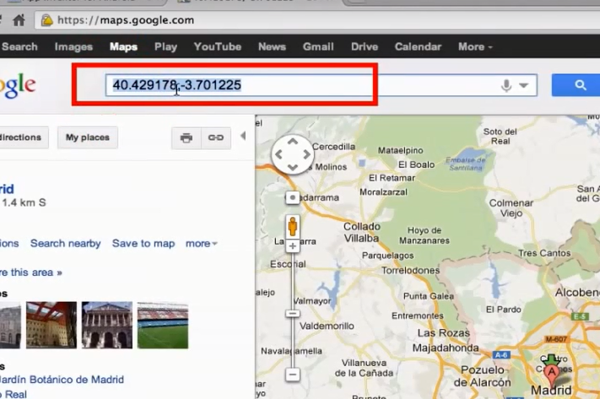

ActivityStarted1.Action = “"android.intent.action.VIEW"

ActivityStarted1.DataUri = “geo:40.417678,-3.699852”

Para agregar marca ?q=

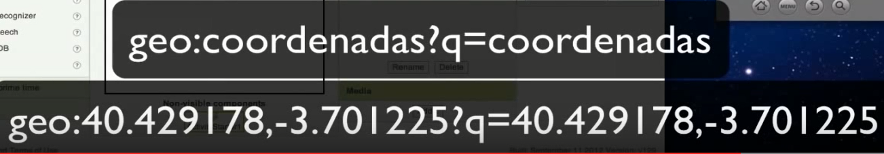

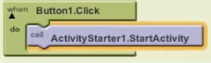

Y aparece otra pantalla con todo el mapa, luego le da return

<http://maps.google.com/maps?q=loc:47.709704,-116.818613>

<http://maps.google.com/maps?q=loc:47.709704,-116.818613>

[http://maps.google.com/maps?q=loc:13.6757674,-89.2798742](http://maps.google.com/maps?q=loc:47.709704,-116.818613)

https://www.google.com.sv/maps/@13.6757674,-89.2798742,15z?hl=es-419

13.6757674,-89.2798742

https://www.google.com.sv/maps/@13.6757674,-89.2798742,15z?hl=es-419